**Synthesis of glycolysis inhibitor (*E*)-3-(pyridin-3-yl)-1-(pyridin-4-yl)prop-2-en-1-one (**3PO**) and its** **inhibition of HUVEC proliferation alone or in a combination with the multi-kinase inhibitor** sunitinib

**Miroslav Murár1,Jana Horvathová2, Roman Moravčík2, Gabriela Addová3, Michal Zeman2, Andrej Boháč*,1,4**

1 Department of Organic Chemistry, Faculty of Natural Sciences, Comenius University in Bratislava, Mlynská dolina, Ilkovičova 6, 842 15 Bratislava, Slovakia 2 Department of Animal Physiology and Ethology, Faculty of Natural Sciences, Comenius University in Bratislava, Mlynská dolina, Ilkovičova 6, 842 15 Bratislava, Slovakia and 3 Institute of chemistry, Faculty of Natural Sciences, Comenius University in Bratislava, Mlynská dolina, Ilkovičova 6, 842 15 Bratislava, Slovakia; 4 Biomagi, Ltd., Mamateyova 26, 851 04 Bratislava, Slovakia

*Corresponding author, e-mail: andrej.bohac@fns.uniba.sk

The authors JH and AB contributed equally to writing this paper.

On behalf of all authors, the corresponding author states that there is no conflict of interest.

Contents

Figures of 1H- and 13C-NMR spectra of 3PO 2

Figures of HSQC, HMBCspectra of 3PO and its diagram of HMBC analysis 3

Figures of IR and MS spectra of 3PO 4

A synthesis of 3PO in the presence of Et2NH 5

A proposed enamine mechanism for the synthesis of 3PO in the presence of Et2NH 7

# Figures of 1H- and 13C-NMR spectra of 3PO

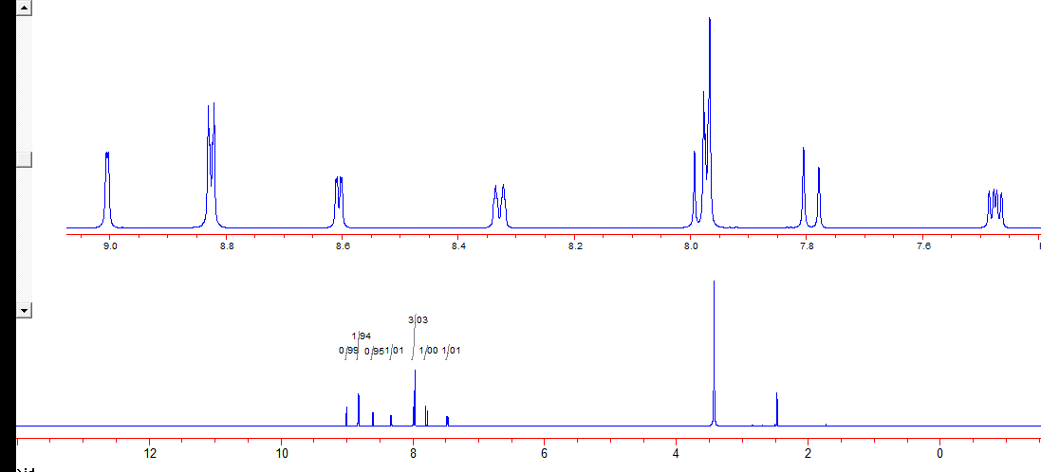

**Fig. S1** 1H-NMR(600 MHz, DMSO-*d6*) spectrum of **3PO** obtained by reaction with AcONa in refluxing AcOH and purified by crystallisation from EtOH

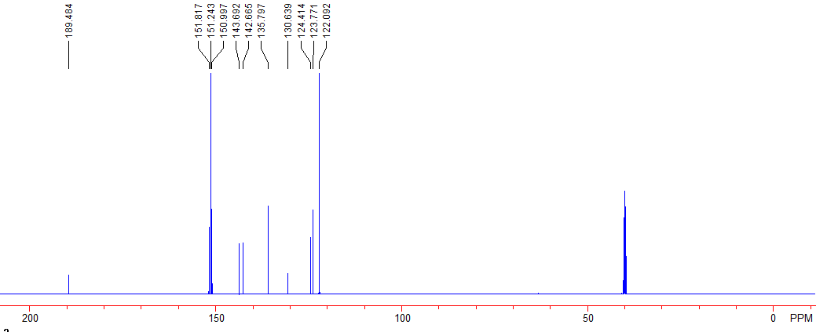

**Fig. S2** 13C-NMR(150 MHz, DMSO-*d6*) spectrum of **3PO**

# Figures of HSQC, HMBCspectra of 3PO and its diagram of HMBC analysis

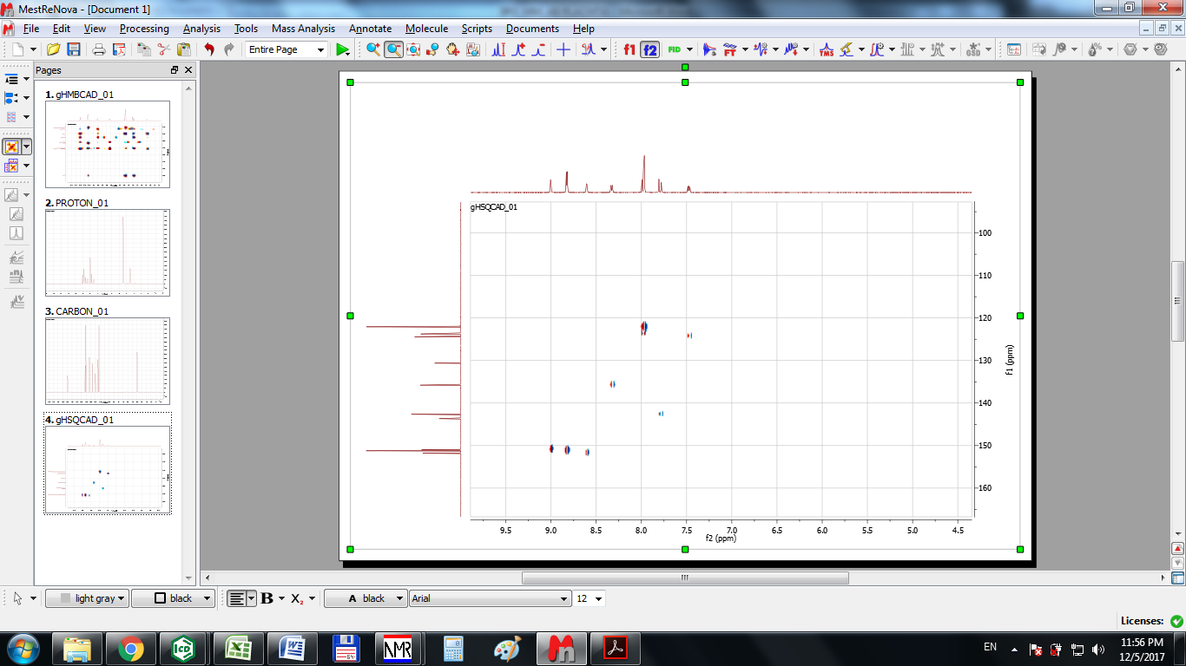

**Fig. S3** HSQC **(**DMSO-*d6*) spectrum of **3PO**



**Fig. S4** HMBC **(**DMSO-*d6*) spectrum of **3PO**



**Fig. S5** A diagram of paired interactions ofH-C signals in **3PO** from HMBC **(**DMSO-*d6*) spectrum

# Figures of IR and MS spectra of 3PO

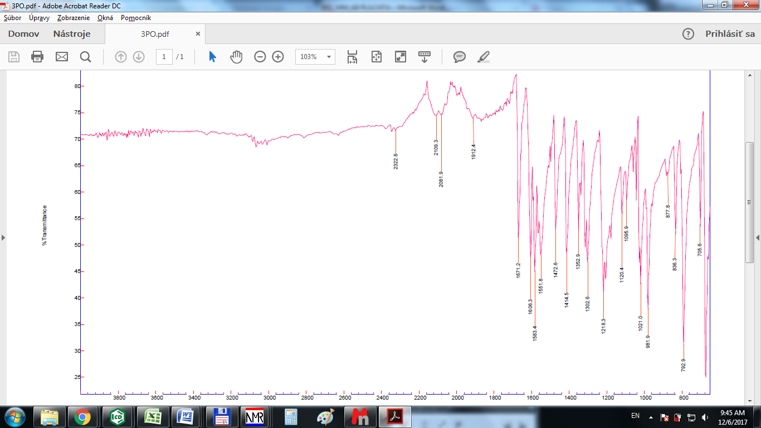

**Fig. S6** FT IR(solid, cm-1) spectrum of **3PO**

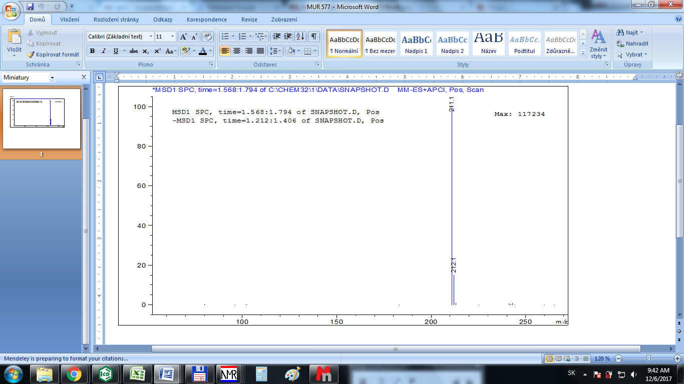

**Fig. S7** MS (ESI m/z) spectrum of **3PO** obtained in a positive mode

# A synthesis of 3PO in the presence of Et2NH

The synthesis of **3PO** was performed according the reaction described in the literature (Durinda et al. 1966 and 1967).



**Scheme S1** The synthesis of **3PO** from **1** and **2** by Et2NHat RT in THF

Diethylamine 171 uL (121 mg, 1.65 mmol, 1.00 mol eq) was added dropwise to a solution of 200 mg (1.65 mmol, 1.00 mol eq) pyridinylethanone **2** in 5 ml of THF (abs). The mixture was stirred at RT within 1 h. Afterwards a solution of 177 mg (1.65 mmol, 1.00 mol eq) nicotinaldehyde **1** in 5 ml of THF (abs) was added within 30 min and the reaction was stirred overnight at RT. Then TLC analysis confirmed presence of a new spot (comparable by its position with the standard of **3PO**) together with traces of starting materials **1** and **2** and four spots of more polar by-products. The mixture was cooled to 0 °C and 10 ml of 2 M HCl (aq) was added by stirring within 5 min. Then the reaction was adjusted to pH 8 by 10 % of NaOH (aq). The final mixture was extracted by EA (2 x 40 ml) and combined organic layer dried over Na2SO4, filtered and evaporated under vacuum by RVO to give 340 mg of a crude product that was further purified by FLC on Silica to yield 40.0 mg (0.19 mmol, 12 %) of product **3** (**3PO**) together with 30 mg (0.280 mmol, 17 %) of **1** and30 mg (0.247 mmol, 15 mol %) of un-reacted **2**. Obtained 1H-NMR (600 MHz, DMSO-*d6*) spectrum confirmed the structure of **3PO** (**3**). The same reaction was performed also in MeOH instead of THF. In this case the reaction was faster, no **3PO** was present and only more polar side products were produced.

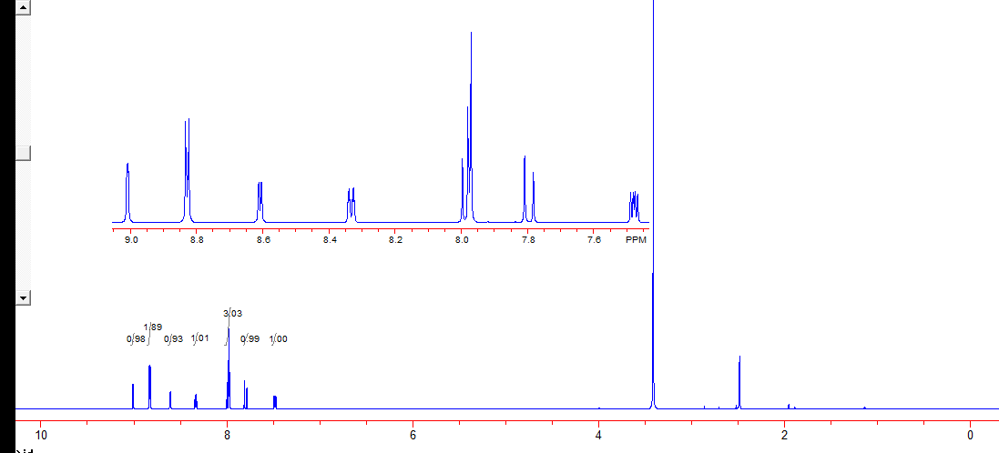

**Fig. S8** The 1H-NMR (600 MHz, DMSO-*d6*) spectrum of **3PO** obtained from the reaction performed with Et2NH after FLC purification (Scheme S1)

# A proposed enamine mechanism for the synthesis of 3PO in the presence of Et2NH

For the synthesis of **3PO** in the presence of Et2NH we proposed an enamine based mechanism **(Scheme S2)** as an alternative to the Claisen-Schmidt condensation that can prefer a production of undesirable polar side products. Both reaction mechanisms can perform and this is probably a reason of a low 12 % yield of **3PO** obtained by these conditions.



**Scheme S2** Proposed mechanism for a synthesis of **3PO** in the presence of Et2NH. Pyridinylethanone **2** andEt2NH react to an enamine **2a** that can subsequently attack the nicotinaldehyde **1** to produce **3PO** precursors **3a** and/or **3b** that are more resistant to nucleophilic species usually destroying **3PO** product in a direct reaction between **1** and **2** catalysed by NaOH, K2CO3 or Et3N. Intermediates **3a** and/or **3b** are precursors of **3PO** that can be liberated on the end of the reaction after its acidic workup.

**References**

**Durinda J**, Kolena J, Szücs L, Krasnec L, Heger J (1967) Study of adrenal cortex inhibitors of the amphenone group. I. Azachalcones Ceskoslovenska farmacie 16: 14-15.

**Durinda J,** Szucs L, Krasnec L, Heger J, Springer V, Kolena J, Keleti J (1966) Chemistry and biological properties of azachalcones, Acta Facultatis Pharmaceuticae Bohemoslovenicae 12: 89-129. Chem. Abstr. 1968 68: 114494y